**EXCEL ASSIGNMENT-6**

**Q1.** Fill in the table of 2016 sales by month by store using only 1 SUMIFS Formula

Step-1. Formula = SUMIFS($C$2:$C$150000,$B$2:$B$150000,$E16,$A$2:$A$150000,F$15)

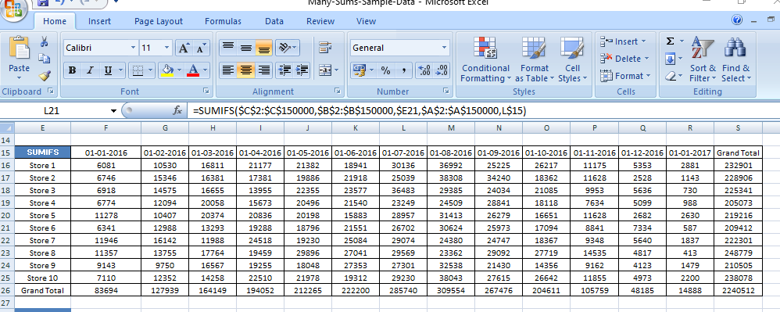

Step-2. Formula = SUMPRODUCT(($C$2:$C$150000)*($B$2:$B$150000=$E3)*($A$2:$A$150000=F$2))

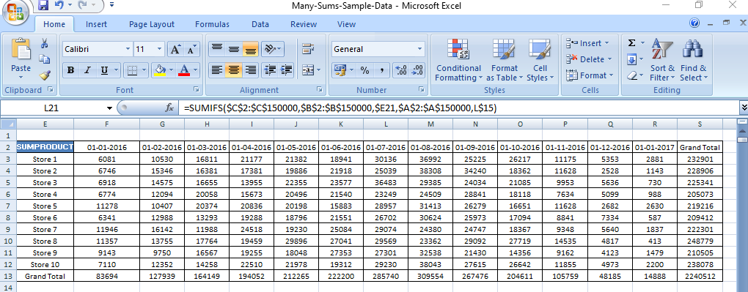

Step-3. Pivot Table by store by month

